CloudHive — Distributed File Management System
Powered by Hadoop HDFS

Abstract
CloudHive is a full-stack, enterprise-grade distributed file management platform built for students and developers who want to understand and demonstrate real-world cloud storage architecture. Users can upload, download, organize, search, and manage files through a modern, secure web interface — while all storage is powered by Hadoop HDFS, distributing file blocks across multiple DataNodes with automatic replication and fault tolerance.
Unlike conventional file management systems that store data on a single server or local folder, CloudHive implements a layered architecture that decouples the client, API services, metadata persistence, and distributed storage — mirroring how platforms like Google Drive and AWS S3 work under the hood.
The project also includes a built-in Admin Dashboard to monitor cluster health, node status, storage usage, and replication metrics.

Objectives
- Build a secure, production-quality web-based file management application.
- Use Hadoop HDFS as the primary storage backend instead of a local filesystem.
- Demonstrate real distributed systems concepts: block replication, fault tolerance, and scalability.
- Implement a clean separation of concerns across Client, API, Metadata, and Storage layers.
- Containerize the entire infrastructure using Docker for portability and repeatability.
- Provide an admin panel for real-time cluster monitoring.

Reviewed Technology Stack
Layer | Technology | Justification
Frontend | React.js + Vite | Component-based UI, fast dev experience, modern ecosystem
UI Styling | TailwindCSS + shadcn/ui | Utility-first, consistent design system
Backend | Node.js + Express.js | Lightweight REST API, strong HDFS/streaming support
Authentication | JWT + bcrypt | Stateless auth, secure password hashing
Metadata DB | PostgreSQL + Prisma ORM | Relational integrity for file metadata, type-safe queries
HDFS Client | WebHDFS REST API | Communicate with Hadoop NameNode without native bindings
Distributed Storage | Apache Hadoop HDFS | Block replication, fault tolerance, multi-node storage
Containerization | Docker + Docker Compose | Simulate multi-node HDFS cluster locally
File Streaming | Node.js streams + Multer | Memory-efficient upload/download pipeline
API Testing | Postman / Thunder Client | Manual and automated endpoint testing
NOTE
Why WebHDFS over native HDFS Java API? WebHDFS exposes Hadoop operations over HTTP REST, eliminating the need for Java or native Hadoop client binaries in the Node.js backend. This keeps the stack clean and JavaScript-native.
IMPORTANT
Why Express.js over NestJS? NestJS adds excellent structure but has a steep learning curve and overhead. For a focused academic/demo project, Express.js gives full control, faster setup, and easier debugging — while still being production-capable. NestJS is listed as a future migration path.

Sequential Module Breakdown
Modules are ordered by development dependency — each module builds on the previous one.

Module 1 — Infrastructure & Environment Setup
Goal: Establish the foundation before any application code is written.
Task | Detail
Docker Compose setup | NameNode + 3 DataNodes
HDFS health verification | WebHDFS endpoint testing
PostgreSQL container | Metadata database init
Environment configuration | .env files, port mapping
Project scaffolding | Monorepo or separate client/ & server/ folders
Deliverable: A running HDFS cluster accessible via http://localhost:9870 and a connected PostgreSQL instance.

Module 2 — User Authentication Module
Goal: Secure the application before any file operations.
Feature | Detail
User Registration | Name, email, password (hashed with bcrypt)
User Login | Returns signed JWT access token
Token Validation | Middleware to protect all file routes
Logout | Token invalidation / client-side removal
DB Schema | users table via Prisma
Deliverable: /api/auth/register, /api/auth/login, /api/auth/logout endpoints + protected route middleware.

Module 3 — Metadata Module
Goal: Track all file information in PostgreSQL independently of HDFS.
Attribute | Type | Description
file_id | UUID | Primary key
file_name | String | Original filename
owner_id | FK → users | Uploader reference
file_size | Integer | Bytes
mime_type | String | e.g. application/pdf
hdfs_path | String | Full HDFS path
folder_path | String | Virtual folder structure
uploaded_at | Timestamp | Upload datetime
download_count | Integer | Tracks popularity
is_deleted | Boolean | Soft delete flag
Deliverable: Prisma schema, migrations, and CRUD service layer for file metadata.

Module 4 — File Upload Module
Goal: Accept files from the frontend and store them in HDFS while recording metadata.
Step | Detail
1. Receive file | Multer middleware (multipart/form-data)
2. Validate | Size limits, allowed MIME types
3. Generate HDFS path | /user/{user_id}/{folder}/{uuid}_{filename}
4. Stream to HDFS | Via WebHDFS PUT request
5. Save metadata | Insert record in PostgreSQL
6. Return response | File ID, HDFS path, upload status
Deliverable: POST /api/files/upload endpoint with streaming pipeline.

Module 5 — File Download & Preview Module
Goal: Allow users to retrieve their files from HDFS.
Feature | Detail
Download by ID | Stream file from HDFS to client response
MIME-type headers | Browser decides open vs. download
Increment counter | Update download_count in metadata
Access control | Only owner (or shared users) can download
Deliverable: GET /api/files/:id/download endpoint.

Module 6 — File & Folder Management Module
Goal: Provide full CRUD and organizational operations.
Operation | Endpoint | Description
List files | GET /api/files | All files by user, with filters
Get file info | GET /api/files/:id | Metadata details
Rename file | PATCH /api/files/:id/rename | Updates metadata only
Move to folder | PATCH /api/files/:id/move | Updates folder_path
Delete file | DELETE /api/files/:id | Soft delete + HDFS deletion
Create folder | POST /api/folders | Virtual folder creation
List folders | GET /api/folders | Folder tree for user
Search | GET /api/files/search?q= | Name/type/date search
NOTE
Folders are virtual — they exist only as metadata (folder_path strings). HDFS stores files in a flat path structure. This mirrors how Google Drive organizes files.
Deliverable: Complete file management REST API.

Module 7 — Storage Service Module (HDFS Integration Layer)
Goal: Encapsulate all HDFS communication behind a clean service interface.
Function | Description
writeFile(path, stream) | Upload file blocks to HDFS
readFile(path) | Stream file content from HDFS
deleteFile(path) | Remove file from HDFS
checkNodeStatus() | Query NameNode for cluster health
getStorageReport() | DataNode storage utilization
verifyReplication(path) | Check block replication factor
Deliverable: hdfsService.js — the single point of contact between backend and HDFS.

Module 8 — Frontend — Core UI Module
Goal: Build the user-facing React application.
Component | Description
Login / Register Page | Auth forms with validation
Dashboard / File Explorer | Grid/list view of files & folders
Upload Zone | Drag-and-drop with progress bar
File Card | Name, size, date, actions menu
Folder Navigation | Breadcrumb-based folder traversal
Search Bar | Real-time file search
Context Menu | Rename, move, delete, download actions
Deliverable: Fully functional React frontend connected to the backend API.

Module 9 — Admin Dashboard Module
Goal: Provide cluster monitoring and system health visibility.
Widget | Data Source
Cluster Health Status | HDFS NameNode API
Active DataNodes | Node count & status
Failed / Unavailable Nodes | Alert display
Total Storage / Used / Free | HDFS storage report
Replication Factor | Per-file block replication
Total Users | PostgreSQL users count
Total Files Stored | PostgreSQL files count
Upload Activity Chart | Time-series upload history
Deliverable: Admin panel (protected route) with live HDFS metrics.

Module 10 — Testing & Documentation Module
Goal: Validate correctness and produce deliverable documentation.
Task | Tool
API endpoint testing | Postman collection
HDFS fault tolerance test | Bring down DataNode, verify file access
Upload/download pipeline test | Large file streaming
Auth security test | Token expiry, unauthorized access
README & setup guide | Markdown docs
Final report / presentation | IEEE-format project report
Deliverable: Test results, API docs, and project report.

System Architecture Diagram

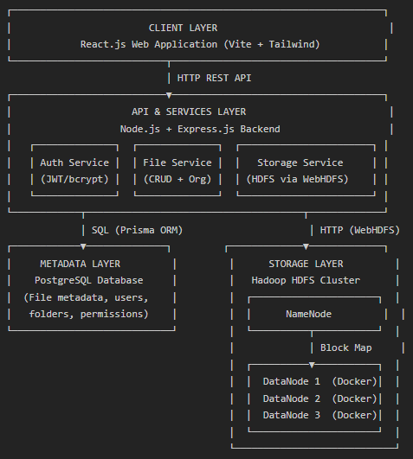

Data Flow — File Upload

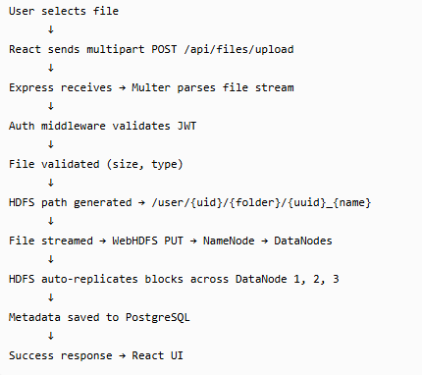

Development Phases & Timeline

Phase | Modules | Estimated Time
Phase 1 — Setup | M1: Infrastructure | Week 1
Phase 2 — Auth | M2: Authentication, M3: Metadata Schema | Week 1–2
Phase 3 — Core | M4: Upload, M5: Download, M6: File Management | Week 2–3
Phase 4 — HDFS | M7: Storage Service | Week 3
Phase 5 — UI | M8: Frontend | Week 3–4
Phase 6 — Admin | M9: Admin Dashboard | Week 4–5
Phase 7 — QA | M10: Testing & Docs | Week 5–6

Future Enhancements

Enhancement | Priority
File sharing with permissions (public/private links) | High
File versioning & Recycle Bin | High
In-browser file preview (PDF, images, video) | Medium
Data encryption at rest (AES-256) | Medium
File deduplication using content hashing | Medium
Activity logging & email notifications | Low
Desktop sync client (Electron) | Low
Mobile app (React Native) | Low
Migrate to NestJS backend | Low

Why CloudHive Is Different
Typical Student Project | CloudHive
User → Backend → Local /uploads Folder | User → React App → Express API → PostgreSQL + Hadoop HDFS
Single point of failure | 3x block replication across DataNodes
No metadata management | Full relational metadata layer
No monitoring | Admin dashboard with live cluster metrics
Manual setup | One-command Docker Compose cluster

IMPORTANT
This project demonstrates both full-stack web development and distributed systems engineering — a rare combination that bridges software and infrastructure disciplines.

